SAMYUKTHA M-23BTT035
SENSOR:LIGHT SENSOR
1. Definition
A light sensor is an electronic device that detects the intensity of light falling on it and converts this light energy into an electrical signal such as voltage or current. It is widely used in automatic and smart electronic systems.

2. Features of Light Sensor
- High Sensitivity: Able to detect even small changes in light intensity.
- Fast Response Time: Quickly reacts when light levels increase or decrease.
- Low Power Consumption: Suitable for portable and battery-operated devices.
- Compact Size: Small in size, making it easy to integrate into circuits.
- Wide Detection Range: Can operate in both low and high light conditions.
- Reliable Operation: Provides consistent performance over long periods.

3. Applications of Light Sensor
Light sensors are used in many real-life applications, such as:
- Automatic Street Lighting Systems: Turns lights ON at night and OFF during the day.
- Mobile Phones: Adjusts screen brightness automatically based on surrounding light.
- Solar Energy Systems: Helps solar panels track sunlight for maximum efficiency.
- Security Systems: Detects intruders by sensing interruption in light.
- Industrial Automation: Used in object detection and counting systems.
- Smart Home Systems: Controls indoor lighting automatically.
- Camera Systems: Adjusts exposure and brightness for better image quality.

4. Working Principle of Light Sensor
A light sensor works based on the principle of the photoelectric effect, where light energy is converted into electrical energy.
Step-by-Step Working:
- Light falls on the surface of the sensor.
- The sensor material absorbs the light energy.
- This causes a change in its electrical properties.
- The change is converted into an electrical signal.
- The signal is sent to a circuit or controller to perform an action.
Example:
- In an LDR (Light Dependent Resistor):
  - Resistance decreases when light intensity increases.
- In a Photodiode:
  - Current increases when light intensity increases.

5. Conclusion
A light sensor is an important component in modern electronic systems. It helps in automation, energy saving, and improving user convenience by detecting light and responding accordingly. Its wide range of applications makes it essential in both simple and advanced technologies.
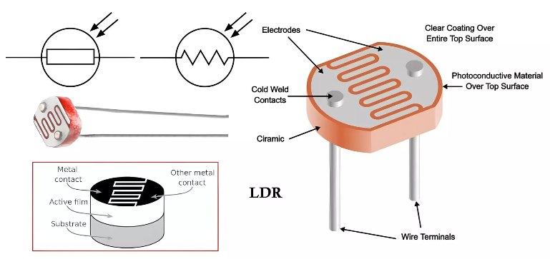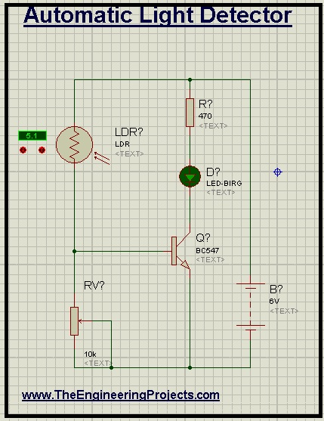

Solenoid Valve Actuators:
1. Definition
A solenoid valve actuator is an electromechanical device that uses an electric current to generate a magnetic field, which in turn controls the opening and closing of a valve. It is commonly used to control the flow of liquids or gases automatically.

2. Features of Solenoid Valve Actuators
- Fast Operation: Opens and closes quickly when energized.
- Simple Design: Fewer moving parts, making it easy to maintain.
- Compact Size: Suitable for small and large systems.
- Remote Control Capability: Can be operated electrically from a distance.
- Low Power Consumption: Efficient for continuous use.
- Reliable Performance: Works consistently under various conditions.

3. Applications of Solenoid Valve Actuators
- Industrial Automation: Controls fluid flow in machines.
- Water Treatment Systems: Regulates water flow.
- Pneumatic Systems: Controls air pressure and flow.
- Automobile Systems: Used in fuel injection and cooling systems.
- Home Appliances: Found in washing machines and dishwashers.
- Medical Equipment: Controls gases and fluids in devices.

4. Working Principle of Solenoid Valve Actuator
A solenoid valve actuator works based on the principle of electromagnetism.
Step-by-Step Working:
- When electric current passes through the solenoid coil, a magnetic field is created.
- This magnetic field attracts a movable iron core (plunger).
- The plunger moves upward or downward.
- This movement opens or closes the valve.
- When the power is turned OFF, a spring returns the plunger to its original position.

5. Types of Solenoid Valves
- Normally Closed (NC): Valve remains closed when power is OFF.
- Normally Open (NO): Valve remains open when power is OFF.
- Direct Acting Valve: Operates directly using electromagnetic force.
- Pilot Operated Valve: Uses system pressure to assist operation.

6. Conclusion
Solenoid valve actuators are essential components in automated systems. They provide precise and efficient control of fluid and gas flow, making them widely used in industrial, domestic, and medical applications.
